Grenswaarde Controlle

Package: Controller

Class: Pulbic_Objective_Card_Controller

Lijn: 23 – 32

Code om te testen: Cards.size() >= 3

|  |  |  |  |
| --- | --- | --- | --- |
|  | 2 | 3 | 4 |
| Cards.size() >= 3 |  | x | x |
| Cards.size() > 3 |  |  | x |
| Cards.size() <= 3 | x | x |  |
| Cards.size() < 3 | x |  |  |
| Cards.size() == 3 |  | x |  |
| Cards.size() != 3 | x |  | x |
| Lichte variant |  | x | x |
| Normale variant | x | x | x |

Pairwise testing

Package: controller

Class ToolCard_Controller

if (chosenCard.hasDoubleSurroundingColor(receiverX, receiverY, dice.getColor())

&& chosenCard.hasSurroundingDice(receiverX, receiverY))

|  |  |  |
| --- | --- | --- |
| A | B | A&&B |
| 1 | 0 | 0 |
| 0 | 1 | 0 |
| 1 | 1 | 1 |
| 0 | 0 | 0 |

ProcesCyclusTesting

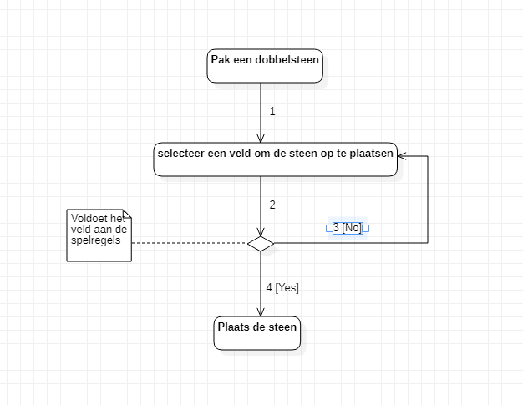

|  |  |  |  |
| --- | --- | --- | --- |
| Knooppunt | Inkomend | Uitgaand | Combinaties |
| Pak een steen | - | 1 | 1 |
| Selecteer een veld | 1,3 | 2 | 1-2 |
| Plaats een steen | 4 | - | 4 |

Test route: 1,2,3,4